1

**Audit & Assurance Products and Solutions Innovation**

Operating Manual - Azure

**Defines infrastructure, operations and support details around Microsoft Azure use of the application**

Audit Online Application

**Web v5.1**

|  |  |
| --- | --- |
| **Author:** | **Ghosh Anindya** |
| **Electronic File Name:** | **Audit Online v5.1 Operating Manual – Azure** |
| **Version:** | **5.1** |
| **Date Released:** | **July 17, 2021** |

Document Version control Information

|  |  |  |  |
| --- | --- | --- | --- |
| Version | Date | Additions/Modifications | Prepared/Revised By |
| 1.0 | March 27th, 2018 | Initial Draft | Han Yi |
| 2.0 | April 3rd, 2018 | Updates based on EMS online v2.0 release | Han Yi |
| 2.1 | May 18, 2018 | Updates based on EMS online v2.1 release | Han Yi |
| 2.2 | July 12, 2018 | Updates based on EMS online v2.2 release respect to IP addresses | Han Yi |
| 2.3 | October 05, 2018 | Updates based on EMS online v2.3 release respect to member firm onboarding process and secret rotation | Anindya Ghosh |
| 3.0 | March 2, 2019 | Updated based on current design and new apps | Anindya Ghosh |
| 3.1 | June 8,2019 | Updated based on current design and new apps | Anindya Ghosh |
| 5.1 | July 17 2021 | Updated based on current design and new apps | Naveen Jaini Vanessa Minik |

Table of Contents

Audit Online Application Design and Architecture 4

Azure Resources 5

Primary Environment 5

Secondary/BCP Environment 7

WorkflowOnline Environment 10

WorkflowOnline /BCP Environment 11

Configuration for Azure Sql Servers and CosmosDb Servers 12

Azure Environment Information 13

ASEs and Resource Groups 13

ASE External IP Address 14

Audit Online Public IPs 14

AD App IDs 15

Administrative Access Rights to Production Data 15

Release Definitions 16

Deployment Approvals 16

Staging Environment Deployment 17

Production Deployment 17

“Secrets” 19

Data Encryption 20

Pre-condition 20

Steps to Deploy PowerBI Reports 21

Member firm Onboarding Procedure 28

Legal Hold Procedures 30

US ITS Platform Services Support Model 31

Appendix 32

Appendix I – Alerts Configuration 32

Emails for Alerts Notifications 33

# Audit Online Application Design and Architecture

Audit Online is a three-component solution.

* Member firm component – This component has API that integrates with single-page app hosted in the cloud by the Central component. Member firm component is deployed on-prem in Member firm infrastructure.
* Central component – This component has ADC, AUDITONLINE, and API. ADC and AUDITONLINE are single-page web applications. Central component is deployed in Azure using PaaS resources
* Workflow Online Central Component – This component will be an Azure Cloud Native solution where all data is stored in Member Firm specific containers. This has been introduced to support RADC for Levvia & Omnia engagement files. WFO component is deployed in the Azure using Pass resources

Member firm and Central components works together through API to create business value to users. Below diagram explains the high-level architecture of Audit Online and WFO.

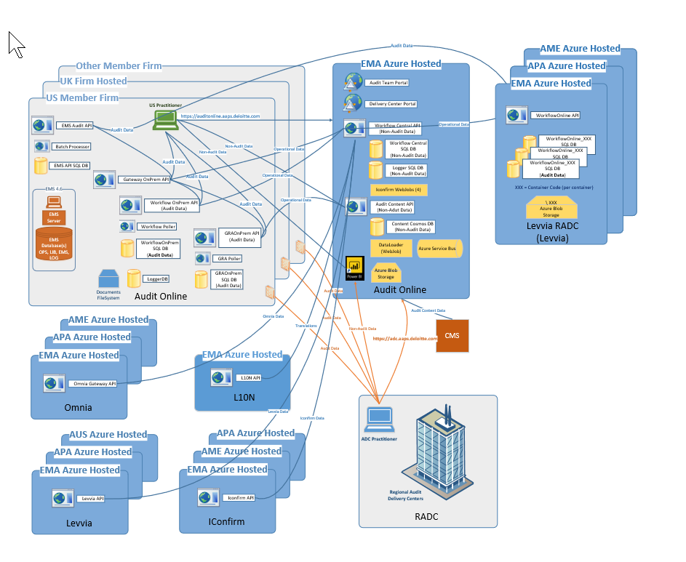

# Azure Resources

Audit Online Central is deployed and set up in two regions for application and data redundancy. Primary region is in West Europe (NL) and Secondary region that is used for disaster recovery/BCP is in North Europe (IR). Databases are geo-replicated between two regions. Application Service Environments (ASEs) are used to secure PaaS resources (web apps and web jobs). Azure Sql Server and Cosmos DB is configured with IP filtering to only allow traffic from ASEs and Azure services.

Workflow Online central is deployed and set up in all 3 regions for application and data redundancy.

Below is the listing of all Azure resources in both primary and BCP environments for Audit online and WFO:

## Primary Environment

Below are resources that are provisioned in the primary environment.

|  |  |  |  |
| --- | --- | --- | --- |
| Name | Type | Region | Note |
| KV | Key Vault | West Europe | Stores connection string |
| ASP | App Service Plan | West Europe | App Service Plan for App Services |
| WFC | App Service | West Europe | RADC Web API |
| ADC | App Service | West Europe | Single-page RADC web site |
| Audit Online | App Service | West Europe | Single-page CFT (client facing team) web site |
| Content | App Service | West Europe | Content Web API |
| Content-WebJob | App Service | West Europe | Content Web Job to process library content updates |
| Central-Webjob | App  Service | West  Europe | Central  Web job to process IConfirm updates |
| Primary Azure Sql | Azure Sql Logical Server | West Europe | Primary Azure Sql Logical Server |
| WorkflowCentral | Azure Sql Database | West Europe | Database to store RADC metadata |
| WorkflowCentralCache | Azure Sql Database | West Europe | Database to store temporaty user cache information |
| WorkflowCentralArchive | Azure Sql  Database | West  Europe | Database to  Store inactive request Data |
| DALoggerDB | Azure Sql Database | West Europe | Database to store application logs |
| Elastic Pool | Azure Sql Elastic Pool | West Europe | Azure Sql elastic pool that provides connection pools to the four Azure databases |
| CosmosDb | Azure CosmosDb | West Europe | CosmosDb to store content information |
| Service Bus | Service Bus | West Europe | ServiceBus used for messaging between compoentes |
| Blob Storage | Storage Account | West Europe | Store blobs for content packages and PKL files for machine learning module |
| Azure Data  Factory | Data  factory | West  Europe | Data Factory is used for Integration and transforming data at scale |
| Redis Cache | Azure Cache  For Redis | West  Europe | Redis Cache is a temporary storge component area where the data is stored so that in feature, Data can be served faster |

## Secondary/BCP Environment

Below are resources that are provisioned in the secondary/BCP environment.

|  |  |  |  |
| --- | --- | --- | --- |
| Name | Type | Region | Note |
| KV | Key Vault | North Europe | Stores connection string |
| ASP | App Service Plan | North Europe | App Service Plan for App Services |
| WFC | App Service | North Europe | RADC Web API |
| ADC | App Service | North Europe | Single-page RADC web site |
| Audit Online | App Service | West Europe | Single-page CFT (client facing team) web site |
| Content | App Service | North Europe | Content Web API |
| Content-WebJob | App Service | North Europe | Content Web Job to process library content updates |
| Secondary Azure Sql | Azure Sql Logical Server | North Europe | Secondary Azure Sql Logical Server (for disaster recovery) |
| WorkflowCentral | Azure Sql Database | North Europe | Geo-replicated with same database in the primary |
| WorkflowCentralCache | Azure Sql Database | North Europe | Geo-replicated with same database in the primary |
| WorkflowCentralArchive | Azure Sql Database | North Europe | Geo-replicated with same database in the primary |
| DALoggerDB | Azure Sql Database | North Europe | Geo-replicated with same database in the primary |
| Elastic Pool | Azure Sql Elastic Pool | North Europe | Azure Elastic pool for the secondary Azure Sql server |
| Secondaray CosmosDb | Azure CosmosDb | North Europe | This resource does not exists. We want to list this item here to indicate that replication to North Europe region has been configured |
| Service Bus | Service Bus | North Europe | Secondary sevice bus for secondary/BCP environment |
| Blob Storage | Storage Account | North Europe | Store blobs for content packages and PKL files for machine learning module |
| Azure Data  Factory | Data  factory | North  Europe | Data Factory is used for Integration and transforming data at scale |
| Redis Cache | Azure Cache  For Redis | North  Europe | Redis Cache is a temporary storge component area where the data is stored so that in feature, Data can be served faster |



Note: App Service Environments (ASEs) are also in use that are not depicted in above figure. ASEs provide secure enclosed environment for Web Apps and Web Jobs.

## WorkflowOnline Environment

Below are resources that are provisioned in the WFO environment.

|  |  |  |  |
| --- | --- | --- | --- |
| Name | Type | Region | Note |
| KV | Key Vault | ALL 3 Regions | Stores connection string |
| ASP | App Service Plan | ALL 3  Regions | App Service Plan for App Services |
| WFO | App Service | ALL 3  Regions | App Service to redirect |
| Elastic Pool | Azure Sql Elastic Pool | ALL 3  Regions | Azure Elastic pool for the Azure Sql server |
| DALoggerDB | Azure Sql Database | ALL 3  Regions | Database to store application logs |
| WorkflowOnlineCache | Azure Sql Database | ALL 3  Regions | Database to store temporary user cache information |
| WorkflowOnline_XX | Azure Sql Database | ALL 3  Regions | Member firm specific Database to store data |
| Azure Sql | Azure Sql Logical Server | ALL 3  Regions | Secondary Azure Sql Logical Server |
| Blob Storage | Storage Account | ALL 3  Regions | Store blobs for content packages and PKL files for machine learning module |

## WorkflowOnline /BCP Environment

Below are resources that are provisioned in the WorkflowOnline/BCP environment.

|  |  |  |  |
| --- | --- | --- | --- |
| Name | Type | Region | Note |
| KV | Key Vault | ALL 3 Regions | Stores connection string |
| ASP | App Service Plan | ALL 3  Regions | App Service Plan for App Services |
| WFO | App Service | ALL 3  Regions | App Service to redirect |
| Elastic Pool | Azure Sql Elastic Pool | ALL 3  Regions | Azure Elastic pool for the Azure Sql server |
| DALoggerDB | Azure Sql Database | ALL 3  Regions | Geo-replicated with same database in the primary |
| WorkflowOnlineCache | Azure Sql Database | ALL 3  Regions | Geo-replicated with same database in the primary |
| WorkflowOnline_XX | Azure Sql Database | ALL 3  Regions | Geo-replicated with same database in the primary |
| Azure Sql | Azure Sql Logical Server | ALL 3  Regions | Azure SQL Logical Server |
| Blob Storage | Storage Account | ALL 3  Regions | Store blobs for content packages and PKL files for machine learning module |

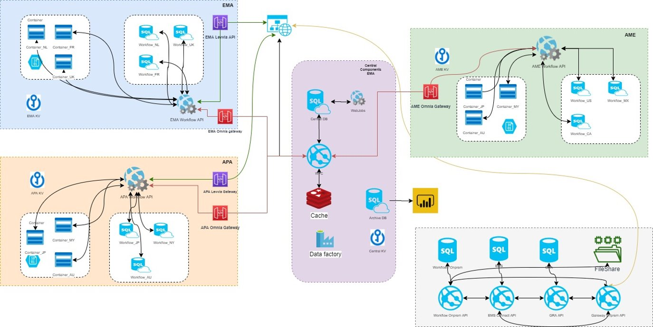

## Configuration for Azure Sql Servers and CosmosDb Servers

Below are additional details on how Azure Sql Servers and CosmosDb servers have been configured.

|  |  |  |  |  |
| --- | --- | --- | --- | --- |
|  | Region | Resource Group | SQL IP Filtering | CosmosDB IP Filtering |
| Primary | West Europe | App-EMSONLINE-EUW-PRD-RG | 52.232.105.233 | 97.76.218.104  77.165.58.99 |
| BCP | North Europe | App-EMSONLINEBCP-EUN-PRD-RG | 52.138.157.210 | Cosmosdb does not exist for BCP |
| WFO | EMA  APA  AME | APP-WORKFLOWONLINE-EUW-PRD-RG  APP-WORKFLOWONLINE-JPE-PRD-RG  APP-WORKFLOWONLINE-USE2-PRD-RG | 52.232.105.233  104.41.160.119  104.46.115.68 | CosmosDB does not exist for WFO |
| WFO BCP | EMA  APA  AME | APP-WORKFLOWONLINEBCP-EUN-PRD-RG  APP-WORKFLOWONLINEBCP-JPW-PRD-RG  APP-WORKFLOWONLINEBCP-USC-PRD-RG | 52.138.157.210  104.215.24.164  40.122.150.174 | CosmosDB does not exist for WFO BCP |

# Azure Environment Information

This section details the production environment information of Azure used for Audit Online and WFO. Deloitte Audit EMA, APA, AME Productions Azure Subscriptions is used to control access to production environments. Access to this subscription is limited to GEO DevOPS team.

## ASEs and Resource Groups

Outbound IP is used to configure Azure Sql firewall settings.

|  |  |  |  |  |
| --- | --- | --- | --- | --- |
| Environment | Resource Group | ASE | VIP (internal) | Outbound IP  (for SQL Firewall) |
| PROD | App-EMSONLINE-EUW-PRD-RG | auditprdprodpubeuwase | 10.122.31.139 | 52.232.105.233 |
| PROD-BCP | App-EMSONLINEBCP-EUN-PRD-RG | auditprdprodpubeunase | 10.122.39.139 | 52.138.157.210 |
| STG | App-EMSONLINE-EUW-STG-RG | auditprdprodpubeuwase | 10.122.31.139 | 52.232.105.233 |
| PROD/STG Build VM | BUILD-EMA-PROD-RG | N/A | 10.122.24.28 | N/A |
| BCP Build VM | BUILD-EMA-EUN-PROD-RG | N/A | 10.122.32.14 | N/A |
| WFO PROD | APP-WORKFLOWONLINE-EUW-PRD-RG  APP-WORKFLOWONLINE-JPE-PRD-RG  APP-WORKFLOWONLINE-USE2-PRD-RG | Auditprdprodpubeuwase  Auditprdjpease01  Auditprduse2ase3 | 10.122.31.139  10.235.2.11  10.122.57.11 | 52.232.105.233  104.41.160.119  104.46.115.68 |
| WFO PROD-BCP | APP-WORKFLOWONLINEBCP-EUN-PRD-RG  APP-WORKFLOWONLINEBCP-JPW-PRD-RG  APP-WORKFLOWONLINEBCP-USC-PRD-RG | Auditprdprodpubeunase  Auditprdjpwase01  Auditbcpuscaseprod1 | 10.122.39.139  10.235.33.11  10.122.49.11 | 52.138.157.210  104.215.24.164  40.122.150.174 |
|  |  |  |  |  |

## ASE External IP Address

|  |  |  |  |
| --- | --- | --- | --- |
| Environment | ASE | External IP Address |  |
| PROD | auditprdprodpubeuwase | 104.40.223.39 |  |
| PROD-BCP | auditprdprodpubeunase | 52.164.242.114 |  |
| STG | auditprdprodpubeuwase | 104.40.223.39 |  |
| WFO | Auditprdprodpubeuwase  Auditprdjpease01  Auditprduse2ase3 | 104.40.223.39  20.188.4.163  104.209.133.123 |  |
| WFO-BCP | Auditprdprodpubeunase  Auditprdjpwase01  Auditbcpuscaseprod1 | 52.164.242.114  40.74.79.228  40.86.74.128 |  |

## Audit Online Public IPs

|  |  |  |
| --- | --- | --- |
| Environment | Public IP |  |
| PROD | 104.45.13.90 | adc.aaps.deloitte.com  pcontent.aaps.deloitte.com  auditonline.aaps.deloitte.com  wfc.aaps.deloitte.com  pcontent-webjob.aaps.deloitte.com  pcentral-webjob.aaps.deloitte.com |
| PROD-BCP | 52.169.123.82 |  |
| STG | 13.93.116.236 | sadc.aaps.deloitte.com  scontent.aaps.deloitte.com  sauditonline.aaps.deloitte.com  swfc.aaps.deloitte.com  scontent-webjob.aaps.deloitte.com  scentral-webjob.aaps.deloitte.com |
| WFO | 104.40.223.39  20.188.4.163  52.167.252.98 | [workflowonlineema.aaps.deloitte.com](https://workflowonlineema.aaps.deloitte.com)  workflowonlineapa.aaps.deloitte.com  workflowonlineame.aaps.deloitte.com |
| WFO-BCP |  |  |
|  |  |  |

## AD App IDs

Secret Keys to below applications will be with EMA DevOPS team.

|  |  |
| --- | --- |
| Environment | App Name |
| PROD | DTTL App0768 EMS Online PROD |
| PROD | DTTL App0768 EMS Online Connect API PROD |
| PROD | DTTL App0768 EMS Online Workflow API PROD |
| PROD | DTTL App0768 EMS Audit Content API PROD |
| PROD | DTTL App0768 EMS GRA Authored Subphase Loader APP PROD |
| PROD | DTTL App0768 Audit Online WorkflowOnline APA PROD |
| PROD | DTTL App0768 Audit Online WorkflowOnline EMA PROD |
| PROD | DTTL App0768 Audit Online WorkflowOnline AME PROD |
| STG | DTTL App0768 EMS Online PREPROD |
| STG | DTTL App0768 EMS Online Connect API PREPROD |
| STG | DTTL App0768 EMS Online Workflow API PREPROD |
| STG | DTTL App0768 EMS Audit Content API NONPROD |
| STG | DTTL App0768 EMS GRA Authored Subphase Loader APP NONPROD |
| STG | DTTL App0768 Audit Online WorkflowOnline APA PREPROD |
| STG | DTTL App0768 Audit Online WorkflowOnline EMA PREPROD |
| STG | DTTL App0768 Audit Online WorkflowOnline AME PREPROD |

## Administrative Access Rights to Production Data

Audit Online Central uses Microsoft Azure Sql Databases and CosmosDb as backend data source. Only NL DevOPS Team (Dutch MF) has access to these databases in EMA AUDIT PROD subscription.

WFO Central uses Microsoft Azure SQL Databases and WFO is in 3 GEO locations. Only GEO-DevOPS (EMA, APA, AME) teams has to these databases in EMA

# Release Definitions

There are three release definitions that are used:

* ProvisionResources-Central – This is used to provision Azure resources
* ProvisionResources-WFO- This is used to provision Azure resources
* DeployDACPAC-Central – This is used to create databases and database objects
* Dacpac-wfo-This is used to create databases
* DeployCode-Central – This is used to deploy code/binaries
* Deploycode-wfo- This is used to deploy code

## Deployment Approvals

All updates to either UAT or Staging or Production environment needs to be planned and goes through automated DevOPS Continuous Integration/Continuous Delivery (CI/CD) pipeline process. Deployment approval mechanism is in place to control. Approval for deployments to environments in EMA AUDIT PROD sub undergo a sequence of approvals.

Staging:

* GDAS DevOps
* EMA DevOps

Production/BCP:

* GDAS DevOps
* Product Owners
* Security Testing
* Tech Controls
* EMA DevOps

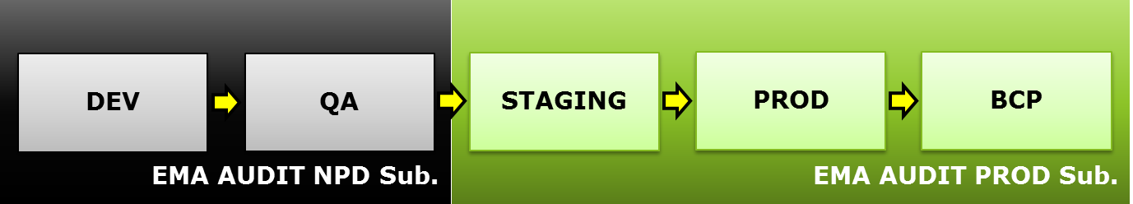

## Staging Environment Deployment

Follow below steps to deploy and setup Staging environment.

NOTE: EMA DEVOPS team must approve every Staging environment deployments

1. Create a new release from [ProvisionResources-Central]
2. Using the release from previous step, provision Azure resources to Staging environment
3. Create a new release from [ProvisionResources-WFO]
4. Using the release from previous step, provision Azure resources to Staging environment
5. Create a new release from [DeployDacpac-Central]
6. Using the release from previous step, deploy database code to Staging environment
7. Create a new release from [DeployDacpac-WFO]
8. Using the release from previous step, deploy database code to Staging environment
9. Create a new release from [DeployCode-Central]
10. Using the release from previous step, deploy application code to Staging environment
11. Create a new release from [DeployCode-WFO]
12. Using the release from previous step, deploy application code to Staging environment
13. Create a new release from [Script-ValidateDeployment] to ensure proper code versions are deployed and database release log is updated.
14. Using browser, ensure app is running properly
15. Confirm PowerBI reports have been deployed properly by testing the reports using browser

## Production Deployment

Follow below steps to deploy and setup Production environment. It is similar to Staging environment. One difference is BCP environment is deployed for production environment.

NOTE: EMA DEVOPS team must approve every Production environment deployment

1. Create a new release from [ProvisionResources-Central]
2. Using the release from previous step, provision Azure resources to Production environment
3. Create a new release from [ProvisionResources-WFO]
4. Using the release from previous step, provision Azure resources to Production environment
5. Create a new release from [DeployDacpac-Central]
6. Using the release from previous step, deploy database code to Production environment
7. Create a new release from [DeployDacpac-WFO]
8. Using the release from previous step, deploy database code to Production environment
9. Create a new release from [DeployCode-Central]
10. Using the release from previous step, deploy application code to Production environment
11. Create a new release from [DeployCode-WFO]
12. Using the release from previous step, deploy application code to Production environment
13. Create a new release from [Script-ValidateDeployment] to ensure proper code versions are deployed and database release log is updated.
14. Using browser, ensure app is running properly
15. Confirm PowerBI reports have been deployed properly by testing the reports using browser
16. Follow below steps to deploy and setup BCP environment:
    1. Using the release from #1, provision BCP resources
    2. Using the release from #3, provision WFO BCP resources
    3. Using the release from #5, deploy database code to BCP environment
    4. Using the release from #7, deploy database code to WFO BCP environment
    5. Using the release from #9, deploy application code to BCP environment
    6. Using the release from #11, deploy application code to WFO BCP environment
    7. Create a new release from [Script-ValidateDeployment] to ensure proper code versions are deployed and database release log is updated.
    8. At this point BCP environment is ready. BCP testing will need to be planned and tested.

# “Secrets”

“Secrets” are information that must be guarded from malicious entities. Audit Online Central has application “secrets”, such as application keys, database connection passwords, etc. All application “secrets” are stored in Azure KeyVault that is only accessible by EMA DevOPS Team (Netherlands member firm). “Secrets” are manually rotated periodically for additional security by running [Script-Rotate Secrets] definition.

WFO central has Application “secrets”, such as application keys, database connection passwords, etc. All application “secrets” are stored in Azure KeyVault that is only accessible by respected GEO-DEVOPS team. “Secrets” are manually rotated periodically for additional security by running [Script-Rotate Secrets WFO] definition.

Following section details how to rotate “secrets” used by Central application and Azure resources

In Audit Online, below “secrets” are in use:

* CosmosDB secret key
* Service Bus secret key
* RedisCache Secret Key
* Storage Account secret key
* Azure SQL Database Connection-Strings
* WorkflowCentral
* WorkflowCentralArchive
* WorkflowCentralCache
* DALoggerDB
* WorkflowCentralArchive-readonly
* WorkflowCentral-readonly
* Azure SQL Database Server Admin password
* Azure SQL Database Server Connection passwords
  + Read-write SQL user password
  + Read-only SQL user password
* SMTP Account password – the above release definition does not rotate SMTP password. SMTP password expires periodically and are rotated manually.

In WFO, below “Secrets” are in use:

* Storage Account secret key
* Azure SQL Database Connection-Strings
* WorkflowCentral (Every MF in that region)
* WorkflowCentralCache
* DALoggerDB
* Azure SQL Database Server Admin password
* Azure SQL Database Server Connection passwords
  + Read-write SQL user password

# Data Encryption

Audit online application uses Azure built-in features and TLS1.2 certificates for the purpose of data encryption. All data at rest such as data in Azure Sql, CosmosDb, and Storage Accounts is encrypted through the use of Azure’s built-in features. Data in motion is encrypted through the use of TLS1.2 certificates.

|  |  |  |
| --- | --- | --- |
| Azure Resource | Data-at-Rest | Data-in-Motion |
| Azure Sql | Transparent Data Encryption | TLS1.2 |
| CosmosDb | Encryption by default | TLS1.2 |
| Storage Account | Storage Service Encryption | TLS1.2 |

PowerBI Setup & Configuration

## Pre-condition

1. PowerBI login user should have PowerBI Pro account access
2. PowerBI Desktop is already installed in user’s laptop
3. Below e-mail groups have been created for PowerBI workspace and report authentication/authorization. Ensure you have been added to ‘Admin’ e-mail groups.

|  |  |  |
| --- | --- | --- |
| E-Mail Group | Purpose | Note |
| [ADCPowerBIAdmins@deloitte.com](mailto:ADCPowerBIAdmins@deloitte.com) | Admin user group for Prod |  |
| [ADCPowerBIUsers@deloitte.com](mailto:ADCPowerBIUsers@deloitte.com) | Non-Admin user group for Prod | Users who needs access to Prod PowerBI Workspace/Reports need to be added to this group |
| [ADCNonProdPowerBIAdmins@deloitte.com](mailto:ADCNonProdPowerBIAdmins@deloitte.com) | Admin user group for Non-prod |  |
| [ADCNonProdPowerBIUsers@deloitte.com](mailto:ADCNonProdPowerBIUsers@deloitte.com) | Non-Admin user group for Non-Prod | Users who needs access to Non-Prod PowerBI Workspace/Reports need to be added to this group |

1. Ensure you have “readonly” database login and password

## Steps to Deploy PowerBI Reports

1. **Create a New PowerBI Workspace**
   1. Login to PowerBI URL <https://app.powerbi.com/>
   2. Click on Workspace tab on the left navigation pane and create a new Workspace “EMS Online Dashboard”
   3. Add below as members
      1. [ADCPowerBIAdmins@deloitte.com](mailto:ADCPowerBIAdmins@deloitte.com) – “Admin”
      2. [ADCPowerBIUsers@deloitte.com](mailto:ADCPowerBIUsers@deloitte.com) – “Member”
   4. Select :
      1. “Private – Only approved members can see what’s inside”
      2. “Members can edit Power BI content”

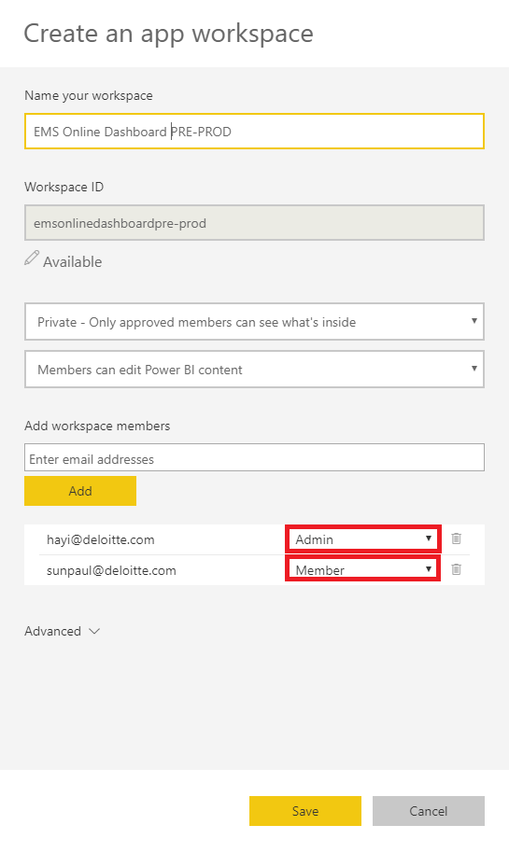

1. **Import and Publish PowerBI Report using PowerBI Desktop**
   1. Change Azure Sql server’s firewall setting to allow incoming traffic from your computer. Once PowerBI Workspace and Report(s) have been configured, remove the firewall changes.
   2. Open PowerBI Desktop
   3. Copy “EmsOnlineDashboard.pbix” from below VSTS to a local temp location

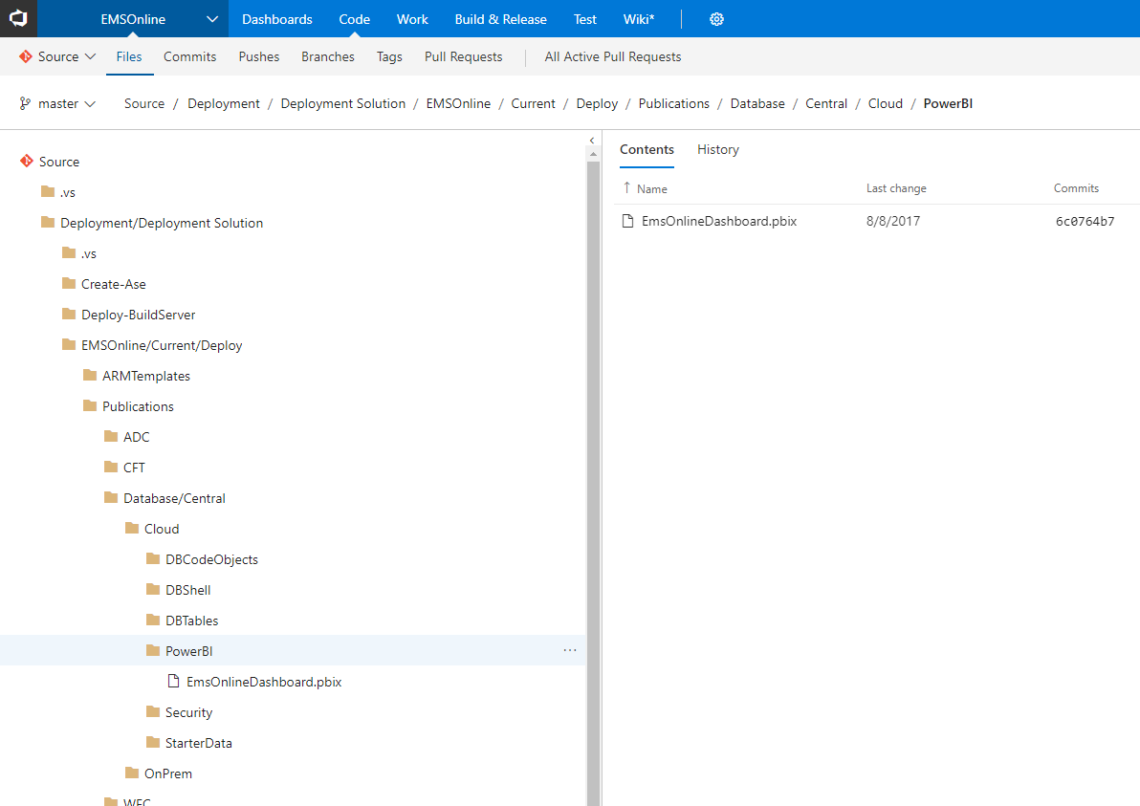

* 1. Open “EmsOnlineDashboard.pbix” from the temp location
  2. Click “Cancel” on the below screen if prompted:

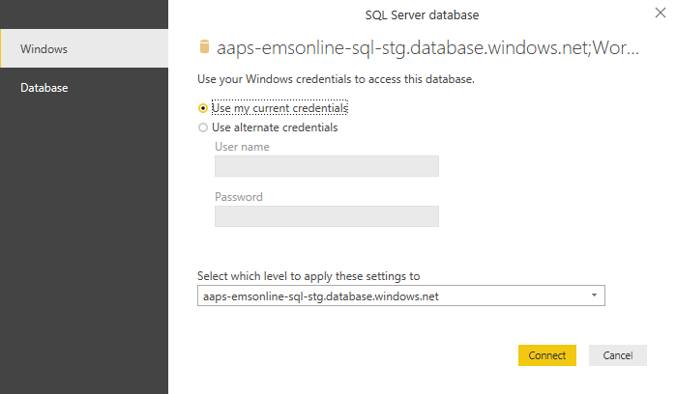

* 1. Click “Data source settings” under “Edit Queries” in the ribbon
  2. Select the existing data source from the popup screen and click “Change Source”

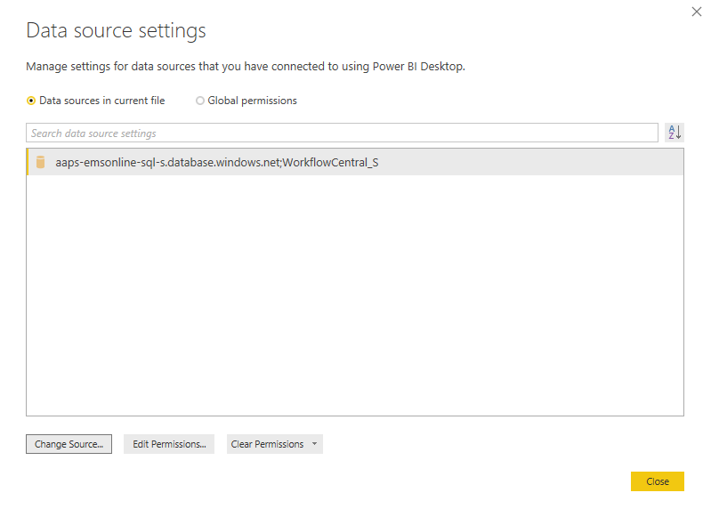

* 1. Provide Production Azure SQL Server Info and database name and click “Ok”
  2. Click “Edit Permissions”

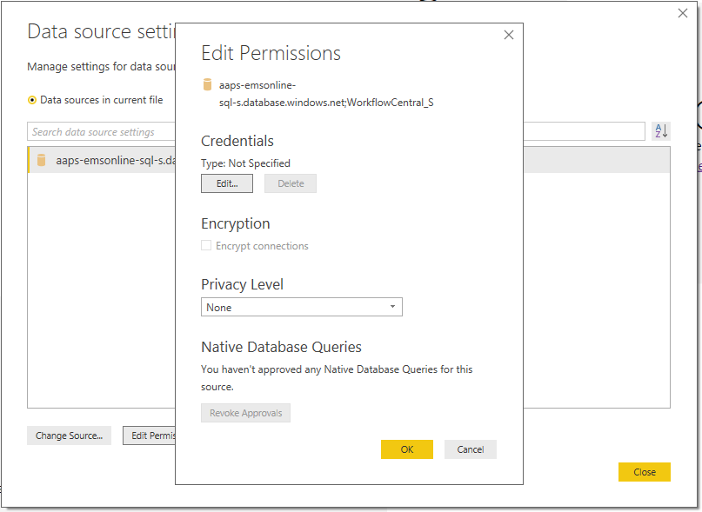

* 1. Click “Edit…” button for Credentials and then click “Database” tab on left navigation. Enter user name and password using “readonly” database login and password. Click “Save”.

Make sure “Encrypt connections” option is checked and “Privacy Level” is set to “None”. Then, click “OK”, and click “Close”

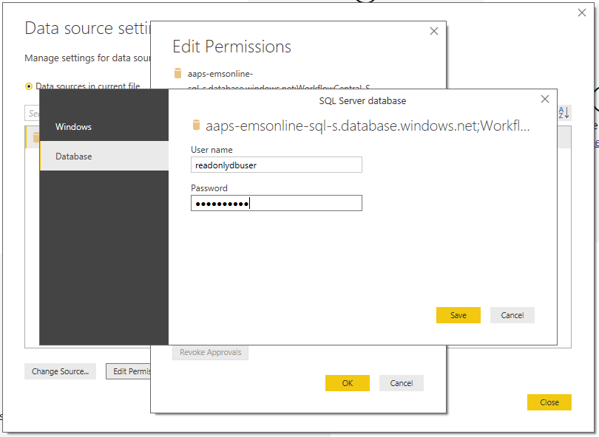

* 1. Click “Refresh” in the ribbon. After “Refresh”, make sure report is displayed in Power BI Desktop window
  2. Click “File”, “Save”
  3. Click “Publish” in the ribbon.

In the dialog window, select the relevant Workspace and then click “Select”. This will publish the local file to PowerBI website.

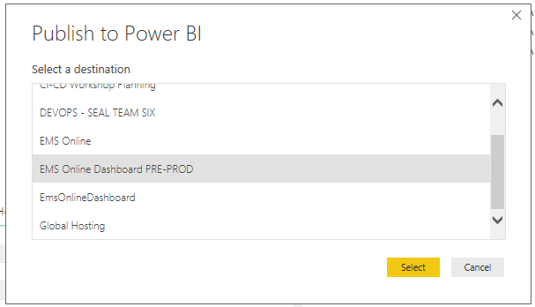

1. **Set Database Credentials and Confirm Published Report**
   1. Go to PowerBI Web site and select the relevant Workspace (one just published).

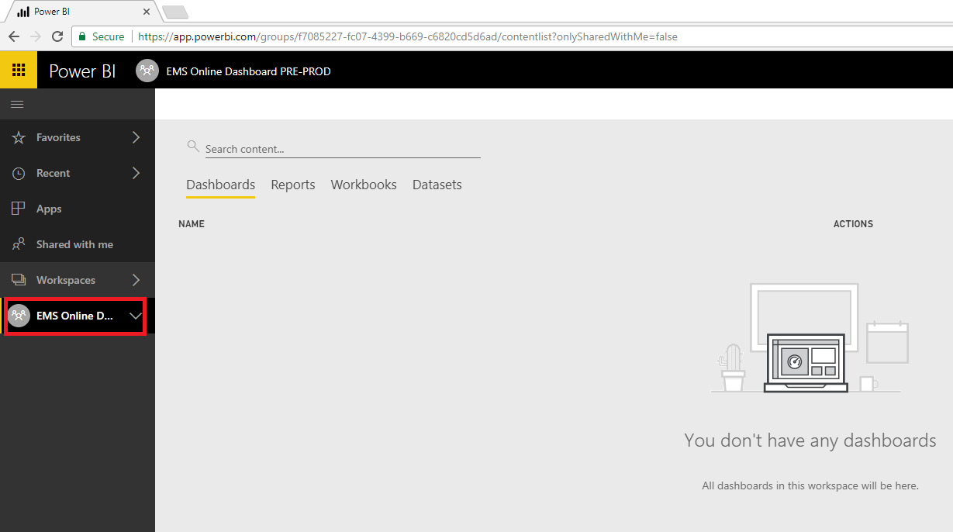

* 1. Click “…” to open DATASETS menu. From the menu, click “DATASET SETTINGS”

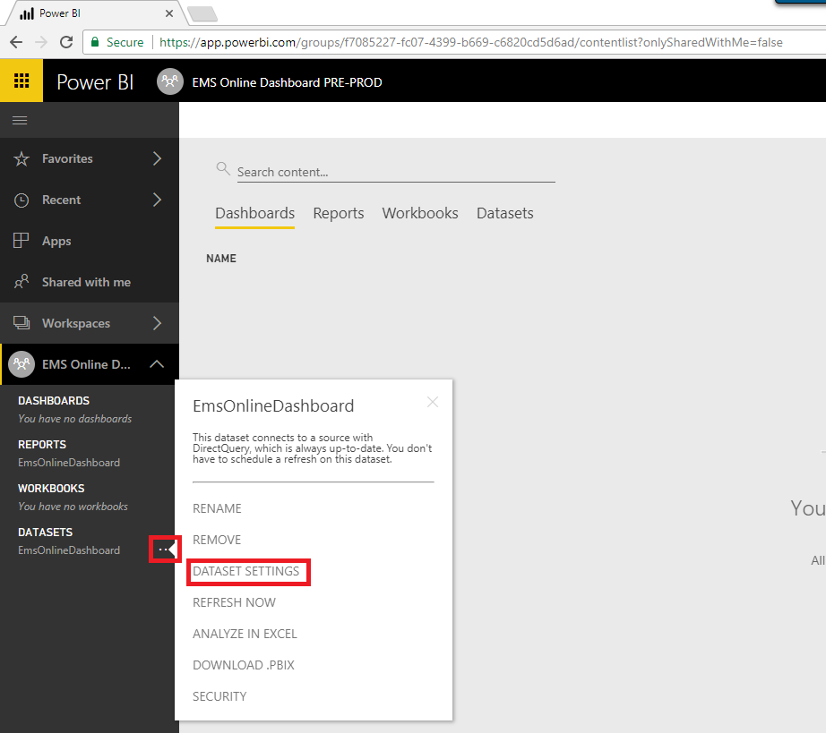

* 1. Click “”Edit credentials”

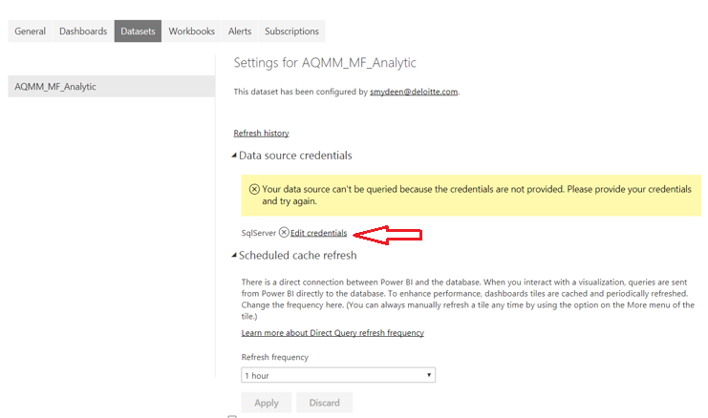

* 1. On the dialog, enter database username and password using “read only” database login and password. Select “Authentication method” as “Basic”. Click “Sign in”

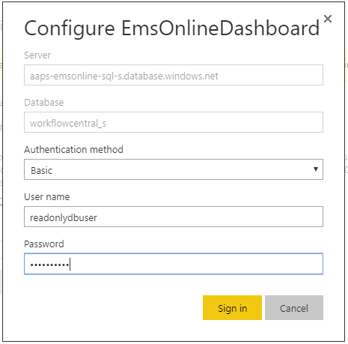

* 1. Select “Refresh Frequency” to a specific value (ex: 1 hour) and Click Apply
  2. Click “…” next to “DATASETS” and select “SECURITY”.
  3. On the “Row-Level Security” page, and add email groups:
     1. [ADCPowerBIAdmins@deloitte.com](mailto:ADCPowerBIAdmins@deloitte.com)
     2. [ADCPowerBIUsers@deloitte.com](mailto:ADCPowerBIUsers@deloitte.com)
  4. Click “Add” and then “Save”
  5. Click on “Reports” from the left navigation pane, actual report will be displayed on the right pane.

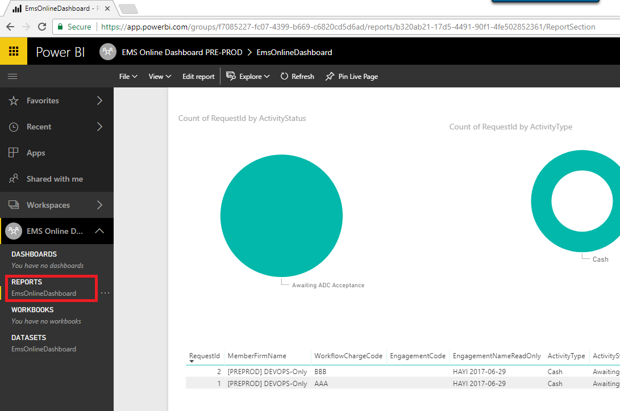

NOTE:

To publish to end-users, follow steps identified by below link and document:

*Distribute Microsoft Power BI Workspace.pdf*

<https://powerbi.microsoft.com/en-us/blog/distribute-to-large-audiences-with-power-bi-apps/>

# Member firm Onboarding Procedure

This section outlines steps to on-board MFs into Audit Online Central.

Note: All the scripts run against WorkflowCentral database

1. **Add a member firm**

Script to be used.



After this is done confirm that the CFT switcher page shows the MemberFirm.

This confirmation will add user details to the person table which is needed for the next step

1. **Add an ADC**

Please use the below script.



Please access ADC website after this step.

1. **Add/Edit holidays for delivery center**



Adding Global Leader

1. **Configuration setup:**

Please refer to configuration table below for a list of items as well as their owners. Several of these configuration items are performed during Audit Delivery Center (ADC) onboarding of a MF via user interactive screen or backend DB scripts.

|  |  |  |  |  |  |
| --- | --- | --- | --- | --- | --- |
| **Level** | **Configuration** | **RADC set-up** | **How** | **Who** | Approval Needed |
| **ADC** | Manage Global Leader |  | Support Ticket/Script | DevOps | Global Leader |
| **MF** | Add User to MF (Add to AD group) |  | Submit Ticket to MF ITS to add to AD/Security group | RADC Scheduler/Team Lead | RADC Leader |

**Dev Ops** – Global Dev Ops group which is responsible for build, upgrade and support of centrally hosted Azure instance.

**Role Based** – There are several roles a user can be assigned within an ADC. Depending on your specific role assignment, your UI screen permissions may vary. Please refer to table below for permission details on each role.

* Global Leader
* RADC Leader
* ADC Admin
* Scheduler
* Team Leader
* Team Member
* Global Admin



# Legal Hold Procedures

This section outlines steps to create legal hold for MF.

1. ServiceNow ticket must be created by MF in order to proceed with Legal Hold request. The ticket must include below information:
   1. MF Id
   2. Engagement File Id
   3. Upload Location
2. Make temporary change to Azure Sql database firewall to allow connection from the machine that will be used to run “Legal Hold” Sql script. (Please refer to DevOPS Runbook for additional details on this)
3. Using Sql Enterprise Management Studio, connect to Azure Sql database
4. In Sql Enterprise Management Studio, copy-paste “Legal Hold” Sql script in the next section.
5. Replace values of two variables in the script using information prepared/gathered as part of the step #1:
   1. @memberfirmId – MF Id
   2. @engagementId – Engagement File Id
6. Using Sql Enterprise Management Studio, execute the “Legal Hold” Sql script
7. Copy-paste result in to a new Excel file
8. Upload the Excel file to Upload Location from the step #1 (ServiceNow ticket).
9. Undo firewall change made in the step #2

Audit Online Support Model with respect to Azure specific incidents

Below diagram depicts how Audit Online application issues will be escalated and supported for both end user issues as well as system generated events from NewRelic Synthetics alert(s) and/or OMS diagnostics notification(s) that have been configure for Audit Online Azure resources.



## US ITS Platform Services Support Model



# Appendix

## Appendix I – Alerts Configuration

Below Azure alerts will be configured for Audit Online.

|  |  |  |  |  |  |
| --- | --- | --- | --- | --- | --- |
| Alert Metric | Azure Resource | Description | Threshold | Performance Monitoring | Threat Monitoring |
| Http 4XX Response Count | App Service | For Http 4xx responses | > 15 min | Yes |  |
| Http 5xx Response Count | App Service | For Http 5xx responses | > 15 min | Yes |  |
| Memory Working Set | App Service | The current amount of memory used by the app, in MiB. | > 15 min |  |  |
| CPU Time | App Service | The amount of CPU consumed by the app, in seconds. | > 15 min |  |  |
| CPU % | App Service Plan | For App Service Plan CPU % | > 90% in 15 min | Yes |  |
| Memory % | App Service Plan | For App Service Plan memory % | > 90% in 15 min | Yes |  |
| Service Availablity | CosmosDb | For CosmosDb availability | < 100 in 60 min | Yes |  |
| Available Storage | CosmosDb | For CosmosDb storage usage | < 10737418240  in 15-min | Yes |  |
| Serviceapilatency | Key Vault | Overall latency of service api requests | > 15 min |  |  |
| Availability | Key Vault | Vault requests availability | > 100 in 15 min |  |  |
| User Errors | Service Bus | User Errors for Microsoft.ServiceBus | > 15 min |  |  |
| Server Errors | Service Bus | For ServiceBus connection errors | > 15 min | Yes | No |
| Throttled Requests | Service Bus | Throttled Requests for Microsoft.ServiceBus | > 15 min | Yes |  |
| Size | Service Bus | Size of an Queue/Topic in Bytes | > 805306368 in 15 min |  |  |
| Active Connections | Service Bus | Total Active Connections for Microsoft.ServiceBus. | < 5 in 15 min |  |  |
| Incoming Messages | Service Bus | Incoming Messages for Microsoft.ServiceBus | < 5 in 15 min |  |  |
| Storage Percentage | SQL Databases | Data space used percent | > 80 in 15 min |  |  |
| Storage Percentage | SQL Databases | Data space used percent | > 90 in 15 min |  |  |
| Deadlock SQL DB | SQL Databases | Deadlocks | > 5 in 15 min |  |  |
| Blocked by Firewall | SQL Databases | Blocked by firewall | > 5 in 15 min |  |  |
| Connection Failed | SQL Databases | Failed connections | > 5 in 15 min |  |  |
| Storage Percentage | ElasticPool | Data space used percent | > 80 in 15 min |  |  |
| Storage Percentage | ElasticPool | Data space used percent | > 90 in 15 min | Yes |  |
| CPU percent | ElasticPool | CPU percentage | > 80 in 15 min |  |  |
| Availability | Azure Storage | The percentage of availability for the storage service | < 100  in 15-min | Yes |  |
| Percent Processor Time | Redis Cache |  | > 80 in 15 min |  |  |
| Used Memory Percentage | Redis Cache |  | > 80 in 15 min |  |  |
| Cache Miss Rate | Redis Cache |  | > 20 in 15 min |  |  |

### Emails for Alerts Notifications

Below e-mail groups have been set up for Alerts notifications. Please ensure your emails have been added to below e-mail groups:

|  |  |  |
| --- | --- | --- |
| E-Mail Group Address | Purpose |  |
| [EMSOnlineAlerts@deloitte.com](mailto:EMSOnlineAlerts@deloitte.com) | Non-threat monitoring alerts |  |
| [EMSOnlineSecurityAlerts@deloitte.com](mailto:EMSOnlineSecurityAlerts@deloitte.com) | Threat monitoring alerts |  |